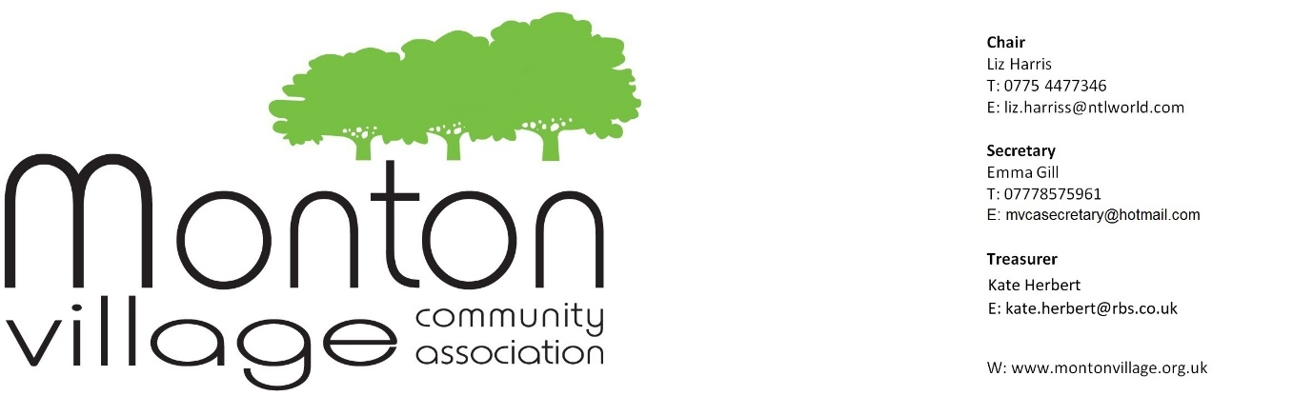
Minutes of the MVCA meeting: 31st May, 2017
Dates for your diaries:
Monton Community Festival meeting – Wednesday, 7th June at 6.00 pm in the Memorial Hall at the Unitarian Church, Monton Green
June MVCA meeting – This is will be about the Festival only - Wednesday, 28th June at 7.00, Memorial Hall, Unitarian Church
August – no MVCA meeting
September MVCA meeting - Wednesday, 27th September at 7.00, Memorial Hall, Unitarian Church
Monton Film Club – the final Friday of every month – in the Unitarian Church
Monton Community Festival – Saturday, July 1st
Monton Christmas Event – 2nd December

Attendees: Liz Harris / Florence McCarthy / Stanley Reeves / Debbie Reeves / Jackie Jones / Pam Ward / Ross Stevenson / Stef Lorenz / Jan Phelan / Siobhan Youd / Rachel White / Rosemary Boardman / Chris Bentley / Ann Rooney / Mark Rooney / Cllr Peter Wheeler / Maxine Coyle
Apologies: Emma Gill / Cllr Michael Wheeler / Judith Gibson / Paula Gibson / PCSO Tony Fletcher / Stephanie Cahill
Liz Harris took the Chair and Florence McCarthy took the minutes.

COMMITTEE UPDATES

Finance Update – no report
Update needed from the Treasurer – to be raised at the next Officers’ meeting in June
Christmas Lights
Emma is still pursuing other quotations. If you know of any other registered electricians, who may wish to quote, please let her know at mvcasecretary@hotmail.com

Environment – Maxine Coyle
- Parking issues - Cllr Peter Wheeler read out a proposed email that he is planning to send out to Paul Dennett, outlining the various car parking related issues that have arisen in recent years and months in Monton. Areas covered are parking throughout many areas of Monton, not just the car park and speeding. If you have any comments for Cllr Wheeler, please send them to councillor.pwheeler@salford.go.uk

- Planning applications
  - Vincent’s Chemist has had no-one approach him to rent out his current pharmacy shop.
  - Allison’s Estate Agents has now gone on-line, and the office on the high street will close.
  - Espera is now a beauty shop
  - Motorcycle shop – Stanley and Debbie Reeves (new owners) attended the meeting and reported that planning permission had been granted. The proposed balcony will have restricted use between 12 – 9 pm. They will be offering BBQ steaks and pizzas.

- Alley gating – Lansdowne and Crawford – Approval for this has now been passed. A date needs to be agreed for the work to take place. Peter Wheeler will contact Urban Vision to progress.
Monton Community Festival 2017
- Plans are well underway.
- If you would like to volunteer to help on the day, please contact Rachel White at rachel86_allstar@hotmail.com
- Liz read out a Safety for Events notice from SCC, in light of the recent terrorist attack in Manchester, as our Festival is in an open public area. Protocol is needed for the day, for all volunteers. Liz to progress.
- We shall have security on the day, as usual – SIA approved company.
- Could we ask for the PCSOs to be on duty that day? Liz to contact Tony Fletcher.
- After the discussion, Liz proposed (seconded by Siobhan) to keep security being managed by the security company that we have engaged with already. Unanimously voted through (exact numbers not available at the time of issuing these minutes).
- Next Festival meeting is on Wednesday, 7th June at 6.00 pm
- Liz proposed (Ross seconded) that the next MVCA meeting discusses the Festival, rather than normal MVCA issues. Again unanimously voted through (exact numbers not available at the time of issuing these minutes).
Monton Community Festival 2018
- We are now actively seeking a Festival Director for 2018, as Liz Harris is unable to commit to this in a voluntary capacity any longer, given her other work commitments.
- Jan Phelan as Deputy Chair circulated a proposed job description and potential salary at May’s meeting – this is being progressed.
- The job advert will be put on social media and the noticeboard in the village.
Church Liaison – Rev Anna Jarvis
- Christmas event was discussed and it was agreed by the Church Wardens / Trustees that MVCA may use the Church hall between 12 – 5 on December 2nd for our Christmas event. A huge thank you to Monton Unitarian Church for being so accommodating.

Social Events – Jackie Jones
- Following on from the AGM in March, the number one social event that caught people’s eye was the cruise on the Bridgewater Canal / with afternoon tea, and the second one was a quiz night and possibly a wine club.
- Jackie will explore these ideas and set some dates / venues.
Membership – Maxine Coyle
- Leaflet drop (along with summer festival leaflet drop) – if you are interested in helping with this, please contact her on 07745 768622 or by email to maxinecoyle@hotmail.com
- Renewal of your membership of MVCA is now available here and on the website www.montonvillage.org.uk
- You can also become a member at the coffee morning in the Church Hall of the Unitarian Church on the 1st Tuesday of every month, between 10-12.
- Maxine to discuss renewals with other membership organisations, to gauge how to improve take up (EPRA, FRECCLES etc.)
- Maxine Coyle to work with Leah Austin (Schools Liaison) so that the booklet can be added to the new starter packs for children starting school.
Gardening – Florence McCarthy
- If you would like to volunteer to help with light gardening on Sundays between 10.00 – 12.00, please contact Florence on 07891 102291. All you need to bring is yourself and a pair of gloves. Meet on the Top Green. Tea and Coffee afterwards will be provided!
- Veterans’ Shelter – there is much need work required, especially to the tiles / gutters / seats / roof. This actually belongs to the council, so Florence has spoken to SCC (Paula Garstang). Paula and Anne Godding to discuss what funding might be available, due to the green being a conservation area. Further details to come.
Retail Liaison – vacant position
- Unfortunately Will has had to resign from this position, as his own workload has grown massively. If you are interested in being the liaison between the traders on the high street and MVCA, please contact Liz on 07754 477346 or liz@montonmarketing.co.uk
Schools Liaison – Leah Austin – no report
Strategic Planning – Ross Stevenson
- The goal is to present a full plan at the AGM for the next two years, focusing on key areas that came out of the local consultations, which are manageable for MVCA.
- However this will be resumed after the Festival.
Marketing Liaison and Membership Liaison – these two positions are still vacant. If you are interested, please contact mvcasecretary@hotmail.com
Christmas Event – Ross Stevenson
- The date of this has now been confirmed – Saturday, December 2nd – further details to come!
Neighbourhood and Night Watch
- No new report

Grant submissions
- The job advert has been put on social media and the noticeboard, but if you are reading this and are interested or know of someone who might feel this is for them, please contact Liz on 07754 477346.
AOB
April AOB items raised by local residents:-
- “As a resident of Monton Road the anti-social behaviour at weekend with people shouting and screaming at around 12.30 am on Friday and Saturday nights has increased over the past month or so. It is therefore a massive concern that Vincent Smiths pharmacy shop (corner of Francis Street) has put in for planning permission for a restaurant. The motorbike shop now has planning permission. I have just walked along Monton road and there are empty glasses and broken bottles near the old lady v shop. What can us, as residents do to stop the council approving more restaurants/ bars. I am constantly objecting to planning permission or licences but do feel that I am the only one, and no notice is taken. Monton is a residential area, although it feels at the minute that the council doesn't support residents at all. Can MVCA do anything collectively?”

As a membership, we discussed this.
Ideas for individuals – If we see anti-social behaviour, you can all report incidences by ringing 101. Contact the brewery. Contact your councillor. Write to licensing@salford.gov.uk
Council - there is a scheme called Best Bar None, run by GMP which is being rolled out in Monton with the licensed premises, which is a Responsible Licensee Scheme promoting best practice and safe practice for all.
Cllr Peter Wheeler attends these meetings.
MVCA – lobby councillors
- Christmas Charity Appeal – Claire Hinton came to speak about JustHelping’s Christmas tree collections, to raise fund for St Ann’s Hospice or other local charities, for example. The scheme runs like this - JustHelping organise the Christmas tree collections, householders are asked to give a donation for their Christmas tree to be collected, and 90% of the money raised goes to charities.
www.charityxmastreecollection.com
To be discussed after the Festival.
- Celebrations and Cake Creations is running a charity do at Monton Sports Club on Friday 29th June for their nominated charities – After Adoption, Arthritis research and Act 4 Africa. This will include a quiz, fun and frolics. More details to follow.

NEXT MEETING will take place on Wednesday, June 28th in the main Memorial Hall at the Unitarian Church – 6.50 pm for a prompt start at 7.00 pm.
PLEASE NOTE THAT THIS MEETING WILL BE A FESTIVAL MEETING, and not the usual monthly MVCA meeting. Apologies for any inconvenience that this might cause.
The next full MVCA meeting will take place on Wednesday, 27th September, as we do not meet in August.

