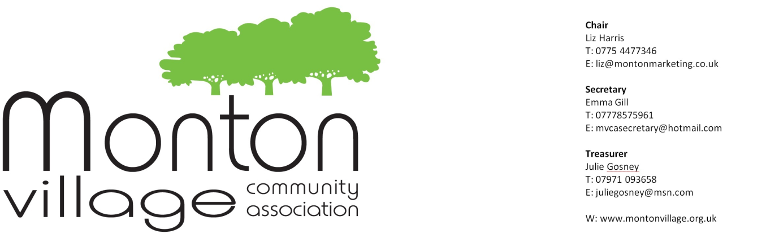
MVCA meeting October 29th, 2014
Attendees: Chris Bentley; Jan Phelan; Maxine Coyle; Tracey Annette; Stef Lorenz; Kamal Khan (Zafrani); Emma Gill; Cllr Michael Wheeler; Cllr Peter Wheeler; Georgina Deer; Hazel Marshall; Florence McCarthy; Pam Ward; Karl Blamire; Joy Watson and Tony Watson (Dementia Havens); Janine McDonald; Judith Gibson; Margaret Roberts; Pam Pickard (Arts and Craft House); Brenda Smith; Liz Harris; Kieran Phelan; Paula Gibson (Celebrations and Cake Creations); Ian Gibson; Cllr Lisa Stone; Jonny Stone; Jane Woodall
Apologies: Debra Egglenton (Beautique); Bruce Thompson (EPRA); Danielle Froom (Nat West); Peter Schofield (Schofield and Sons); Mark Brady; Bee Morrison; Steve Slater (Worsley Golf Club); Jill Swann-Hunter (City West)
Dates for your diaries:
Next MVCA meeting: Wednesday November 26th at Leos (downstairs at 6.50 pm for a prompt 7.00 pm start)
Christmas Lights Switch On: Thursday 27th November from 5.00
Gardening on the Green: November 16th and 23rd, 10.00 – 12.00 (bring gloves and if you have secateurs or shears, please bring them too – not a necessity)

Morrison Community Funding Award
- MVCA has been awarded £50 and the committee was hoping that a member of the Morrisons team would be able to come to present the cheque at the meeting. Unfortunately this was not possible on the night, but we would like to thank Morrisons for their support.
Dementia friendly Monton
- Joy and Tony Watson from Dementia Havens spoke about their recent success in Eccles in making it more dementia aware and friendly to people with dementia. This involved engaging with shop owners, giving staff tips on how to recognise people with dementia, as well as stickers to put in shop windows to advise people with dementia and their family and friends that certain shops were dementia friendly.
- It was felt within the meeting that, whilst there was a lot of empathy towards dementia sufferers, we might extend this to a wider audience, with mobility, access issues.
- Decision made at meeting to put together a small plan (to begin with), to be presented at the November meeting to assess how the scheme might be implemented in Monton.
- Action Tracey Annette / Pam Ward / Tony and Joy Watson
Christmas Event – Thursday 27th November
- Poster ready to be distributed
- Tombola prizes can still be dropped off at Celebrations and Cake Creations
- Father Christmas is visiting
- Salford Youth Brass Band and Monton Voices will provide entertainment
Environment
- Some street bins have shop waste in them. Action Maxine Coyle to write to ALL traders to remind them to remove their waste in the appropriate way.
- Private bins in the car park were to be taken away as not being emptied. Action Peter Wheeler to contact David Robinson at the council.
- New coordinator at City West – Jill Swann-Hunter, whom Maxine Coyle is meeting in early November to give her an update on local issues.
- If you see an overflowing bin on a regular basis, please let Maxine know maxinecoyle@hotmail.com
- Tree bases and pavements – sadly we have come to the conclusion from lengthy discussions between Maxine and Urban Vision that there is no funding available. Action Maxine to come up with a proposal for November meeting – pursue or not?
- Why is there no Section 106 money available from the McCarthy and Stone development? http://www.salford.gov.uk/planning-section106intro.htm
Action Peter Wheeler
Planning
- Monton House will be converted in a children’s nursery – spring 2015
- Former Post Office – plans for another food and drink establishment (membership only)
- Mrs Doolittles – will be offices
- Blue Bell – having a new veranda built with outdoor seating
- Selo Deli to be sold as a going concern
- Likewise Ackroyds Fish Shop
- Budgens proposal for a new supermarket – this has gone cold
Parking
- Spaces outside the Blind Pig to be parking for cars, not taxis. Action Peter Wheeler to speak to Tommy Ruck
- Car park – Liz Harris, Chair of MVCA has had no response (to date) from Cllr Derek Antrobus about the delay in any decision about parking, following her email of 8th October, which is very disappointing. She will write to him again, asking for a reply. We are also considering writing to the Letters pages of the local press to complain. Please note that this should be as individual residents or traders, rather than directly representing MVCA). Alternatively you might wish to lodge a request for information, via the Freedom of Information Act. Details of what this is and how to do it can be found here. Social media (Twitter / Facebook) could also be used.
- Algernon Street – Urban Vision has now come up with the funding to set up the scheme for residents’ parking permits. Residents will need to pay £50 per car per annum to have a permit.
- A point was raised by Hazel Marshall about workmen / friends / family etc. - where are they to park, without being fined?
- Parking dispensation can be granted by Traffic Management at the council by ringing 0161 779 4987
- http://www.salford.gov.uk/residentpermits.htm is a useful link for further information

Alan Henning Memorial Fund
- Local resident, Mark Rooney suggested that MVCA might consider a donation to the Alan Henning Memorial Fund. It was decided that this was a personal decision.
- Anyone wishing to donate to the fundraising campaigns can do so by following this link
- There is a second memorial fund in conjunction with the council – details here
- Local businesses can get tamper proof collecting buckets – further details can be found here
Clarendon Cottage School
- We have been approached by the school to see if they can engage more with the local community and MVCA.
- At the moment, with the few volunteers who regularly help out, we do not have much spare capacity or resource.
- MVCA is open to working with all local schools, and would welcome any suggestions from schools about how this could come about.
- If you have any ideas, and would perhaps like to coordinate a small project, please contact Liz Harris by email at liz.harriss@ntlworld.com
Food recycling
- One local resident, Pam Ward complained that her recycling food caddy was not getting emptied. No one else seems to have the same issue, so it was put down to an isolated incident. One trader generously offered the use of their pink lidded garden waste bin, should this happen again. Many thanks.
Access around Monton
- Following on from the discussion with Dementia Havens, it was decided that this topic should be taken up by the working group
- Action Tracey Annette / Pan Ward / Tony and Joy Watson / Janine McDonald

AOB
- Previous discussion about letting local election candidates to MVCA meetings was reviewed by the originator of the idea, local resident, Sara Hughes, who has since decided that this would not be a worthwhile idea. Candidates should come to us to listen!
- February fundraising event for the playground – Action Paula Gibson after Christmas
- Local resident would like to see a bench on the high street – Action Tracey Annette / Pan Ward / Tony and Joy Watson / Janine McDonald
- I ♥ Monton has new discounts which can be found here
- Website – we still need Website Manager, as we cannot progress the new website design and content, without one. Please feel free to pass this onto any family or friends who have the necessary skills / experience of running websites and who you think might be interested in volunteering. Contact Jan Phelan on phelan.family@tesco.net
- Janine McDonald to bring Festival photos on laptop to November meeting
- Local resident, Jane Woodall suggested planting bulbs in the roundabout – this was carried and Florence McCarthy to action
- Stef Lorenz has suggested the table top games (from 2013 festival) could be donated – Dementia Havens will happily take these.
- 11th November at Celebrations and Cake Creations – Christmas preview night + 10% discount

NEXT MEETING will take place in the downstairs function room at Leo’s on Wednesday, 26th November at Leos at 6.50 pm for a prompt 7.00 pm start). We look forward to seeing you there!

