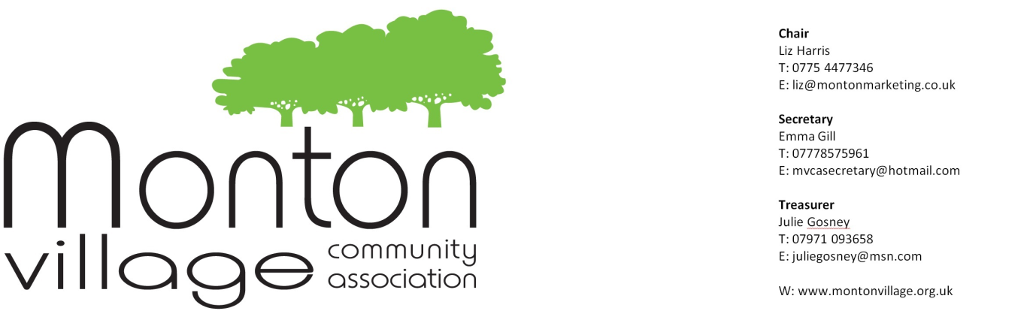
MVCA meeting July 30th, 2014
Attendees: Liz Harris (Chair); Maxine Coyle (outgoing Secretary); Val Kelly; Stef Lorenz; Florence McCarthy; Steve Slater; Christine Bentley; Jane Woodall; Hazel Marshall; Barbara Redford; Janine McDonald; Russell Halter; Cllr Peter Wheeler; Derek Hodgkinson; Paula and Ian Gibson; Bruce Thompson (EPRA); Fred Gorvitt; Pam Ward; Jan Phelan; Kieran Phelan; Sara Hughes; Mark Rooney; Ann Waddell; Tracey Annette; Emma Gill (incoming Secretary); Julie Gosney
The July meeting commenced with a fitting farewell tribute to the outgoing Secretary, Maxine Coyle to thank her for all her hard work over the many years. Maxine has stood down as Secretary but will continue to play a large role in MVCA on both the Environment and Membership Committees.

Venue for MVCA meetings
- Over 2014, since the hotel closed, MVCA has been holding its meetings in several local venues, with varying degrees of success
- Sara Hughes and Emma Gill have done recces in new locations, and would like to suggest the basement of Leo’s Restaurant.
- The advantage to Leo’s is that the downstairs area can be accessed without disturbing diners, as there is a separate entrance. There are toilet facilities, the room will hold up to 20/25 people, it is well lit and the acoustics are good (not too echoey).
- The only consideration is that this arrangement does not come free (unlike other places). Leo would like to support MVCA by offering the downstairs room and would like us to consider making a charity donation of £50, to be split between two charities.
- Sara and I would like to ask you to have a think about this and to email mvcasecretary@hotmail.com by Sunday 14th September, if you are against this proposal.
Social Events
- It was decided that we should have a fund raising evening for the playground in Shackleton Street. Paula Gibson to action.
- Christmas Lights switch on will be Thursday 27th November – save the date!
- Possible fund raising evening in February 2015 – tbc
- Anyone interested in helping or with ideas, please contact Paula at her shop Celebrations & Cake Creations Ltd in Monton
Environment
- Small oval roundabout has now been redesigned in plan and is now with Urban Vision to be actioned.
- Stableford Avenue – please could the committee look into new lighting and the potholes?
- Grass in the park area – Maxine Coyle has spoken to the Environment Department, as City West is not fulfilling its maintenance programme. To be pursued further. We should try to report this to Tim Doyle at onenumber@citywest.org.uk or online via the City West website at http://www.citywesthousingtrust.org.uk/were-about-you/general-enquiries
- Steve Annette and Florence McCarthy’s hanging basket team were warmly congratulated after their efforts to keep the village blooming with their watering efforts.
- Tree bases continue to prove difficult to resolve as quotations are too high. Andrew Meadows has been told and Maxine Coyle has requested a plan of all the trees on the high street, to understand which are on private or council land.
- Bins should be emptied on Fridays – to be monitored.
Membership
- Now at 194 residents and 47 businesses
- Database is being overhauled
- Membership form is on the MVCA website
- Discount scheme is now up and running at 20 local businesses and details can also be found on the website here in this link
- A call for more merchandise – possibly children’s T shirts with I ♥ Monton logo?
Festival
- The committee has been put together – the same as for 2014
- Festival feedback meeting to be organised by Liz Harris
Parking
- Cllr Antrobus has called an extension to the consultation period, which the meeting found unacceptable after all the campaigning and time.
- Liz Harris to write formally from MVCA to Mayor, Ian Stewart to make known MVCA’s feelings of frustration, reflecting also those of the local traders and residents alike.
- If you wish to send an email of your own, with your own comments, please find below the email address of Cllr Derek Antrobus - Councillor.Antrobus@salford.gov.uk
- To contact Mayor Ian Stewart, please click on this link http://www.salford.gov.uk/contactcitymayor.htm
- Alternatively, phone 0161 794 4711 or write to
Salford City Council, Civic Centre, Chorley Road, Swinton, Salford, M27 5FJ
- Taxi spaces outside the Blind Pig – why can’t these be turned into normal parking spaces? Peter Wheeler to look into this.
Bridgewater Canal Workshops
- Three local residents went on two separate workshops to learn more about the regeneration plan.
- More details can be found on the council website http://www.salford.gov.uk/bcc.htm
- More updates to come over the next few months.
Volunteers
- MVCA should look at a plan to encourage more volunteers to get involved.
- To be looked at next meeting in September
Website
- Photos from the summer festival to be uploaded to the website. Action Janine McDonald and Mark Rooney.
- Fresh ideas need to be generated please for the website – what would YOU like to see on your local village website? Please contact Jan Phelan if you have a suggestion at phelan.family@tesco.net
- Val Kelly offered to get involved.
- More guidance was required for people wanting to add content.
Refurbishment of Shackleton Street playground
- The Landfill Trust via SITA, a recycling and resource management company is looking to offer funding for local initiatives.
- Jan Phelan and Joy Dent are spearheading the bid for funding.
- May need as much as £6-7 k as our contribution to match Landfill Trust’s contribution.
- Fundraising events to be planned.
- It was suggested that MVCA might consider providing some money, so a full proposal should be brought to the next meeting for discussion. Stef Lorenz, Julie Gosney and Jan Phelan to discuss prior to next meeting.
- Local families should also be involved to gain their support and suggestions – perhaps an informal presentation at an MVCA meeting or local school?
Gated ginnels
- Tracey Annette and Russell Halter to look into this – there is no funding, and residents may need to get together to raise the money to gate off the ginnels.
AOB
- Residents raised the problem of overcrowding on pavements due to the number of bars now in Monton.
- Budgens’ proposal to put a new supermarket in Monton was roundly rejected by the meeting – Peter Wheeler to pass this onto the Planning Committee.
- Noticeboard – funding is required. Emma Gill to action
- Algernon Street – parking issues are still rife, and no real action from Urban Vision as signage is too expensive.
- New venue for meetings (see above)
- Hanging baskets – when will these need to be removed? At the same time, any old, redundant posters should also be taken down.
- A fund raiser in the spring was suggested – possible venue = bowling club?
- Mrs. Doolittle’s Pet Shop has had to leave due to disrepair of shop, and lack of action by the landlord.
- The pavement area taken over by The Blind Pig has grown bigger and bigger. Can Peter Wheeler help with advising bars what they can and cannot do?

NEXT MEETING will take place in the downstairs function room at Leo’s on Wednesday, September 24th, unless otherwise announced, prior to the meeting.

